https://goo.gl/YFJMSR

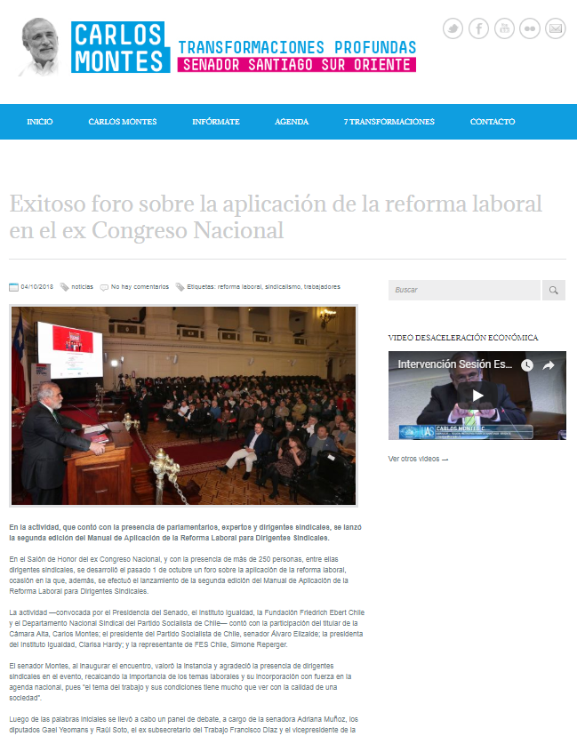
https://goo.gl/fiAwTU

